The Director,
Skill Development Department,
Jammu & Kashmir.

No: KGP/Estt/2025/1867 Dated:26-12-2025

Subject: Furnishing of details regarding occupation of Government Quarters and HRA.
Reference: Your office letter No. DSDD/213/2025-01/e-7820277/1361/-62 dated 24-12-2025.

Sir,
As per the record available, the required details regarding occupation of Government Quarters and HRA deduction by officers/officials at Kashmir Government Polytechnic, Srinagar, are given below as per the prescribed format in the Annexure “A”. This is submitted for your information please.

Yours Faithfully
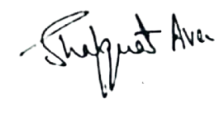

Principal
Kashmir Government Polytechnic College
Srinagar

